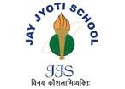
JAY JYOTI SCHOOL, GUNA
STUDENTS OF JJS CONTINUED THEIR WINNING STREAK AS USUAL
EXEMPLARY ACHIEVERS

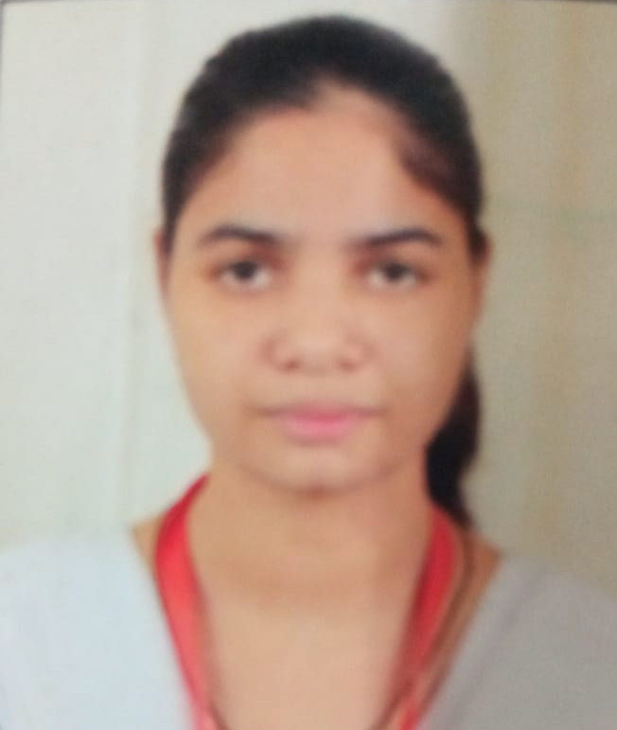
VANDANA DHAKAD
( BATCH 2016-17)
CLASS X CBSE BOARD
NEET -UG, AIR( 23510 RANK),
AIIMS-AIR (4100 RANK)
DEEPAK DHAKAD
(BATCH 2013-14)
CLASS X CBSE BOARD
NEET-UG, AIR(394 RANK),
AIIMS-AIR(344)
UMESH MEENA
( BATCH 2013-14)
CLASS X CBSE BOARD
JEE Adv. , AIR(3557 RANK),
JEE MAINS ,AIR ( 4667 RANK)

DEEPAK DHAKAD
(BATCH 2013-14)
CLASS X CBSE BOARD
NEET-UG, AIR(394 RANK),
AIIMS-AIR(344)

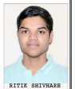

RITIK SHIVHARE
( BATCH 2016-17)
CLASS X CBSE BOARD
NEET -UG, AIR( 23510 RANK)
AIIMS-AIR (4100RANK)

RAMLAKHAN MEENA
( BATCH 2016-17)
CLASS X CBSE BOARD
NEET -UG,AIR( 6149 RANK)
AIIMS-AIR (4100RANK)

The JJS congratulates them for their remarkable achievements
and wishes them more glories and success in the future.

