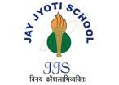
JAY JYOTI SCHOOL, GUNA
STUDENTS OF JJS CONTINUED THEIR WINNING STREAK AS USUAL
SESSION WISE ACADEMIC TOPPERS OF CLASS XII

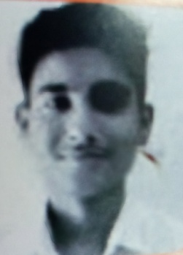 | 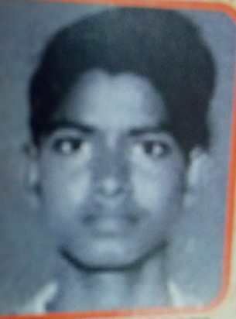 | 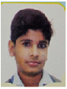
AMAN JAIN  (SESSION-2017-18) | RAHUL PRAJAPATI  (SESSION-2017-18) | ARYAMAN JAIN  (SESSION-18-19)

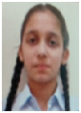 | 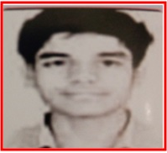
GARGI AGRAWAL  (SESSION-2018-19) | ROHIT SAHU  (SESSION-2018-19)

JJS congratulates them for their remarkable achievements
and wishes them more glories and success in the future.

JAY JYOTI SCHOOL, GUNA
STUDENTS OF JJS CONTINUED THEIR WINNING STREAK AS USUAL
ACADEMIC TOPPERS OF CLASS X

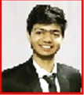

DEEPAK DHAKAD UMESH MEENA
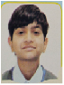

(SESSION-2013-14) (SESSION-2013-14)

SAJAL JAIN SHIVANI SHARMA
(SESSION-2013-14) (SESSION-2014-15)
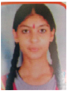


SURESH MEENA SALONI KABRA
(SESSION—2015-16) SESSION—2015-16)
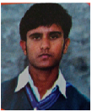
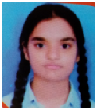

PRIYANSHI KABRA A.R.VISHAL
(SESSION—2015-16) ( SESSION—2015-16)
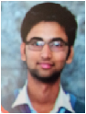
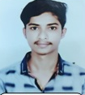
RAMLAKHAN MEENA RAHUL MEENA
(SESSION—2016-17) ( SESSION—2016-17)
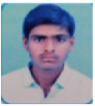

BALDEV MEENA ARYAMAN JAIN
(SESSION—2016-17) ( SESSION—2016-17)
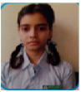
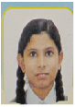

TEJANSHI DAUSHALYA RANU SHARMA
(SESSION—2016-17) ( SESSION—2016-17)
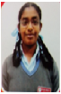

SNEHA SANTHOSH AMAN MEENA
(SESSION—2016-17) ( SESSION—2016-17)
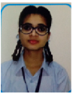
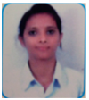
AASHI JAIN YASHASWI LADDHA
(SESSION—2016-17) ( SESSION—2016-17)

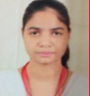
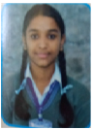

VANDANA DHAKAD YASHASWI LADDHA
(SESSION—2016-17) ( SESSION—2016-17)
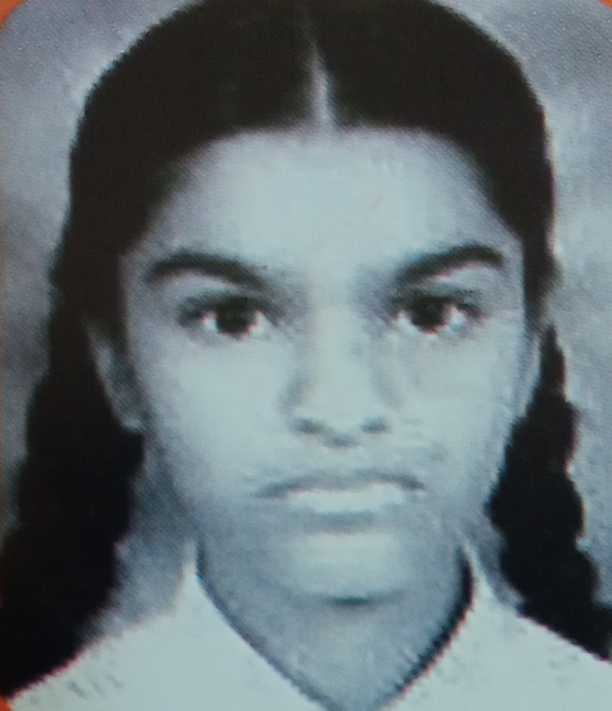

GARGI AGRAWAL KARITKYA MANGAL
(SESSION—2016-17) ( SESSION—2017-18)

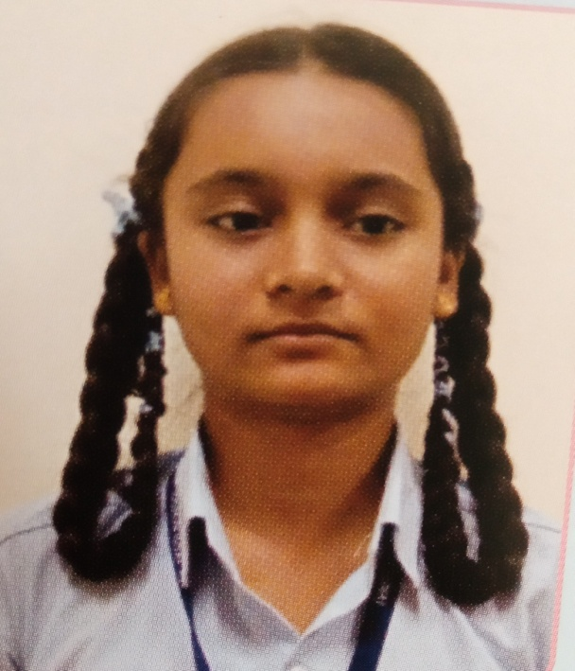

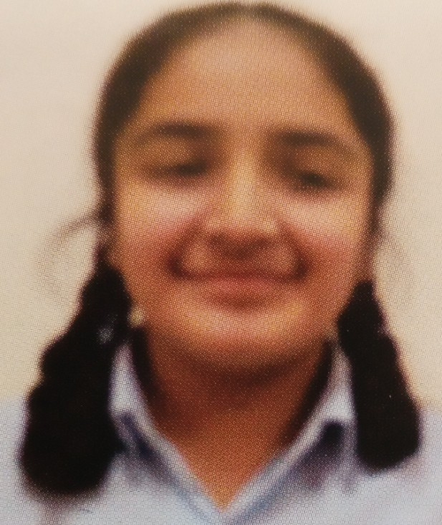
NISHIKA SHARMA SHRISHTY BANSAL
(SESSION—2018-19) ( SESSION—2018-19)
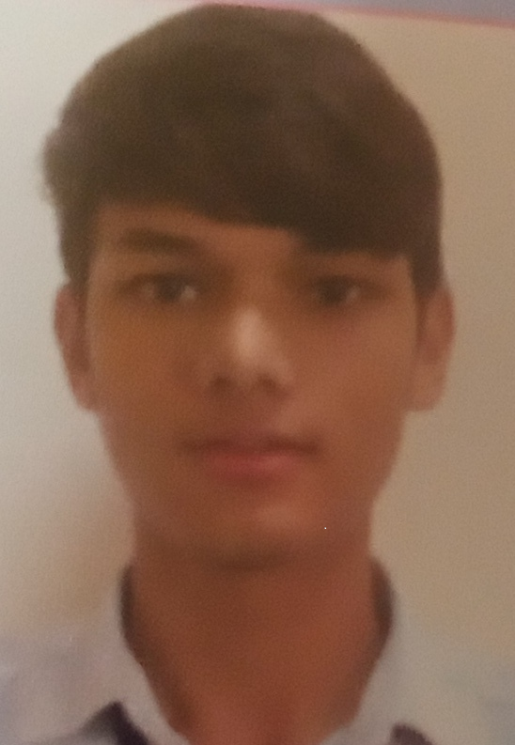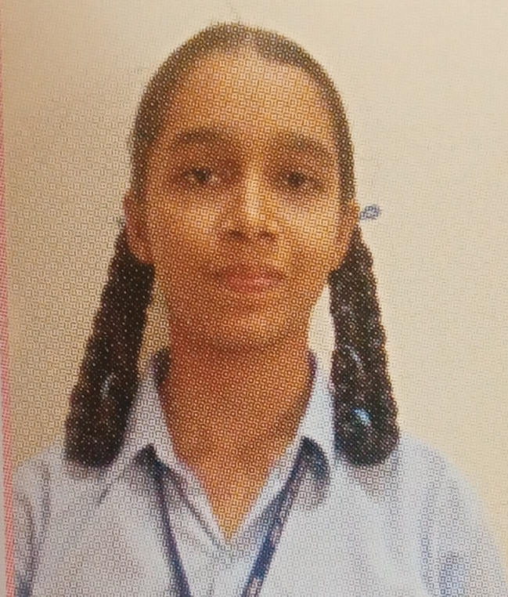
VISHAL MEENA DEVANSHI MISHRA (SESSION—2018-19) ( SESSION—20119-20)

JJS family congratulates them for their remarkable achievements
and wishes them more glories and success in the future.
DEEPAK DHAKAD
(BATCH 2013-14)

